Quotation Template
Biovision Africa Trust would like to invite quotations for the supply of seventy 6-story gardens. The 6-story vertical gardens should be of High-density polyethylene (HDPE)with Ultraviolet lays (UV) and of 10 meters sheet with a diameter of 1.5m & Shade nets 4*25m

Please quote using the template below:
DESCRIPTION | QUANTITY | UNIT PRICE | TOTAL
- A 6 Vertical - story Garden  - Each carries 100+ plants  - 6 stairs height  - Diameter 4.5 feet  - Gauge of Materials (0.4) | 70
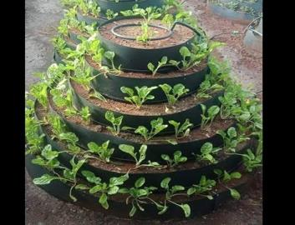
Shade nets 4*25m | 310 pieces
GRAND TOTAL

